Brachial artery
- Continuation of axillary artery beyond lower border of teres major
- Terminates by dividing into radial artery and ulnar artery
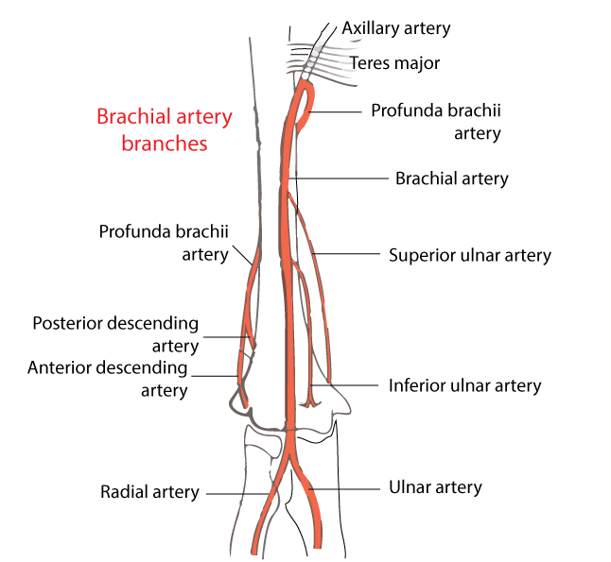

Branches:
  - Muscular branches – to muscles of arm
  - Profunda brachii artery
  - Nutrient artery of humerus
  - Superior ulnar collateral artery
  - Inferior ulnar collateral artery
  - Terminally – radial and ulnar artery

[CLINICAL]Brachial blood pressure measurement – anatomical viewpoint
[NOTE]Riva–Rocci cuff must cover 2/3rd of length of brachial artery
[TIP]]Korotkoff’s sounds are heard over the brachial artery. Brachial artery is located medial to the tendon of biceps brachi just distal to the elbow line.

Anastomoses around elbow joint
Important in cases of injury or surgical ligation of the brachial artery
Arteries involved
- Brachial Artery Branches: Superior ulnar collateral and inferior ulnar collateral arteries.
- Profunda Brachii Artery Branches: Radial collateral artery and middle collateral artery (posterior descending).
- Radial Artery Branches: Radial recurrent artery.
- Ulnar Artery Branches: Anterior and posterior ulnar recurrent arteries.
- Interosseous Artery Branches: Posterior interosseous (recurrent) artery.

